|  |
| --- |
| **San Pablo Road (Beach Boulevard to Atlantic Boulevard)** |

**Project Phase 3A. Schools are back in session. Traffic congestion due to student drop off and pick up is anticipated daily 7AM to 9AM and 2PM to 4PM. A shift west for SB traffic from Osprey Point Dr to North of Beach Blvd is anticipated to be implemented on Sunday Night 9-15.**

Construction – Phase 3A & 3B **Upcoming Work**

**Work planned for next week – 9-02-24 through 9-22-24. DAY AND NIGHTTIME OPERATIONS ARE SCHEDULED**

* Grading for new curb and turn lanes on west side.
* Sod placement days.
* Pavement striping for new asphalt 8/28.
* Asphalt paving nights 9/4&5, 9/08 to 9/19.
* Switch SB traffic from Beach to Osprey Point to outside lane on Sunday night 9-15.
* Construct median islands on south side.
* Signal mast arm placement at Osprey Point.
* Material removal at JEA Easement area.
* Curb & sidewalk installations on West side.
* Light pole installations west side.

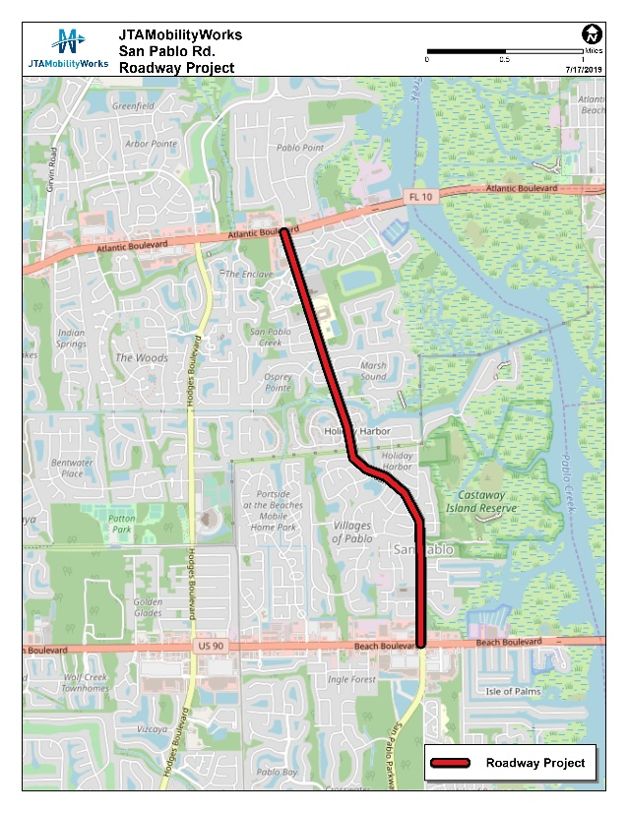

PRIMARY ACTIVITY AREA